Below is an example of a works cited page. Traditionally with MLA formatting, your works cited will be a separate page attached to the end of your paper. However in my class I like to save paper, so you may put your works cited after your final concluding paragraph. You MUST follow the rest of the basic rules as you see below…
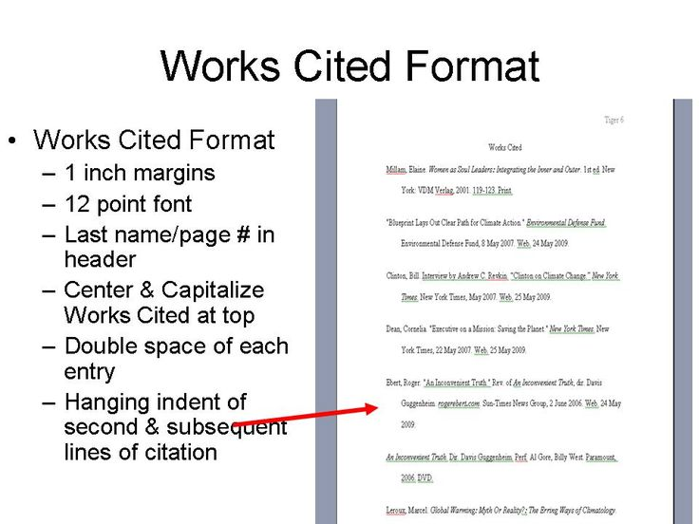
https://www.google.com/search?q=mla+works+cited&biw=1366&bih=673&source=lnms&tbm=isch&sa=X&sqi=2&ved=0CAYQ_AUoAWoVChMIn4Tq-_afyAIVymw-Ch0pWwiq#imgrc=m58XfGE3VXG5pM%3A
Here is my own works cited example…
Smith, 4

Works Cited
De Maupassant, Guy. "The Necklace." The Necklace. American Literature. Web. 30 Sept. 2015. <http://americanliterature.com/author/guy-de-maupassant/short-story/the-necklace>.
Lee, Harper. To Kill a Mockingbird. Philadelphia: Lippincott, 1960. Print.
Poe, Edgar Allan. "The Raven." Poems and Poets. Poetry Foundation. Web. 30 Sept. 2015. <http://www.poetryfoundation.org/poem/178713>.

Taking a closer look:
Now, you have the luxury of using an online MLA organizer such as easybib.com or bibme.org. Both are great resources that can help you track down your resources and fill in the citation information for you. BUT! BUT! BUT! These are computer systems and subject to make mistakes. Therefore, let’s look at what you should have if you did this “manually” or without these resources…
Works Cited
Lee, Harper. To Kill a Mockingbird. Philadelphia: Lippincott, 1960. Print.
Poe, Edgar Allan. "The Raven." Poems and Poets. Poetry Foundation. Web. 30 Sept. 2015. <http://www.poetryfoundation.org/poem/178713>.
Observations
- The first item in citation will be the name of the author: last name, then first name.
--Notice that the citations are in alphabetical order based on the author’s last name.

- Each “chunk” of information will always be separated by a period.

- The second item is the title of the resource. If it’s a book title, it will be in italics. If it’s a poem, short story, or news article, it will be in “ “ quotation marks.

- ***The third chunk of information is the publisher—these are the people who pay or are responsible for producing the materials for the general public. Books will have the City/State of publication, and the name of the publishers using a colon to separate but connect the information. Online resources will usually only have the name of the publishing company.
- ****The third chunk of information for an online resource will be the title of the webpage (also in italics). Sometimes this information will be the same as the title of the resource. Sometimes this information will be missing, or the same as the publisher or overall web page.
--Information such as this will be located either at the very top or bottom of the website.
--If the info is not there, leave it blank…don’t force information if it just isn’t there!

- The next chunks of information vary, depending on the type of source. You will often see the date the resource is published (copyright date). You will also see the type of resource (web, print, etc.). Finally, web sources will need to include the date you accessed the resource in the unique order of day, month, year as well as the website URL.
--MLA loves to change rules every so often, and the newest change is that you are not required to include the URL. HOWEVER, for my class, I WANT YOU TO INCLUDE THE URL.

- Don’t forget the hanging indent quote!

