Directions: to finish our study of Shakespeare’s Othello, you will be writing a series of blogs (3 to be exact). Before you begin those blogs, consider what a blog is? How can it be structured? What will it look like? Read through the mentor texts below, which will help define blogs as well as give you some real life examples…

WHAT IS A BLOG?
by Kenneth Byrd | Go from 0 to 5,000 blog subscribers in 60 days (Click Here)

So What Is a Blog?
Let’s begin with some definitions. A bit dry, we realize, but this is a necessary evil. First we’ll define the word this whole site is based around – blog.
A blog is a frequently updated online personal journal or diary. It is a place to express yourself to the world. A place to share your thoughts and your passions. Really, it’s anything you want it to be. For our purposes we’ll say that a blog is your own website that you are going to update on an ongoing basis. Blog is a short form for the word weblog and the two words are used interchangeably.
Here are a couple of other definitions:
“…the first journalistic model that actually harnesses rather than merely exploits the true democratic nature of the web. It’s a new medium finally finding a unique voice.”–Andrew Sullivan
“[a] collection of posts…short, informal, sometimes controversial, and sometimes deeply personal…with the freshest information at the top.”–Meg Hourihan
Originally blogs were known primarily as places for people to write about their day-to-day activities. Their mundane, everyday tasks became fodder for journal entries. Somehow these writers gained a following and the hobby of blogging was born. Today people write about far more interesting topics, but we’ll get to that in a minute.

Who Blogs?
So who are these fearless people who would be willing to post about their lives in as public a forum as the Internet? They are people just like you. Once the haven of technical know-it-alls, blogging has suddenly caught-on as a legitimate hobby and has entered the mainstream. Every day millions of people, some of whom have no technical ability whatsoever, write on their blogs.

Why Do People Blog?
So you may be asking why anyone would want to have their own blog. We believe the answer lies in the fact that every human has a voice and wishes their voice to be heard. The Internet is a medium that is unparalleled in its reach. Never before have average people like you or me been able to reach a global audience with so little trouble. Bloggers have the opportunity of reaching hundreds or even thousands of people each and every day.
There are still many people who like to share the details of their days. They may post twenty or thirty times a day, detailing when they ate lunch and when they headed home from work. On the other hand there are bloggers who give almost no detail about their lives, but write instead about a hobby or interest of theirs. They may dedicate their blog to something they are passionate about.
In fact, today’s blogs can provide hair tips, up-to-date news, technical information, celebrity scandal, political rumor, gets people involved in volunteering, advice on investments as well as there being blogs on cooking, health, gardening, sport, blogging blogs (this blog) and of course many personal blogs and quite a few strange blogs.

How to Write the Best Blog Post EVER
Written by Kipp Bodnar | @Kippbodnar
7 Traits of Great Blog Posts
1. Actionable - Whether they found the blog post through a search engine , an email, or a social network share, the core reason people click through to an article is to solve a problem. What makes people share a post with others is the actionable insight it provides to solve a problem. Provide clear takeaways and actionable steps in blog posts to ensure your idea resonates with readers.
2. Combined Relevance - Metaphors are a timeless storytelling element. Don't leave metaphors to novelists. They should be an active part of blog posts. Comparing two seemingly different things and drawing connections between them is a valuable way to combine relevance and generate more intense interest in a subject.
3. Urgent - Journalists write articles based on who, what, when, why, and how. As a blogger, answering the "why" isn't enough. Instead, it is critical to answer "why now?" The web is flooded with content. Content that is urgent and timely wins in the race for attention.
4. Visual - Making a blog post visual doesn't mean filling it with images and videos (not that video and images aren't important in blog posts). However, they aren't the only ways to make a blog post visual . Use section headers, numbers, bullets, and other text elements to make it easy for readers to understand your idea quickly.
5. Solution-Based - As we said earlier in this post, on the web, people are looking for solutions. Products aren't solutions. They are part of a solution. Don't cram a blog post full of product content. Instead, provide educational content that runs parallel to your product offering.
6. Entertaining - Informative doesn't mean boring. Just because you sell sheet metal, doesn't mean your business blog can't also be entertaining. Have your shop crew make some fun and timely creations out of sheet metal and post an image or video of each new creation. Have someone outside your company review your blog post to check for entertainment.
7. Definitive - Great blog posts aren't meek or subtle. They are clear, direct, and definitive. Take a stand, make strong word choices, and don't waver on your advice. Be the expert on your topic.
Reactions/Discussion Points:
*So what is a blog? What tips do you find helpful or important from the first two mentor texts?

Directions: Below are some real life blogs. Read and review them for good writing ideas. What do you notice about structure? Organization? Voice? Purpose?

***

#1: Jenny Lawson, The Bloggess

I can’t.
JANUARY 14, 2016
in JUST SAD
Ugh. Just. No.
This morning Victor woke me up and took me to coffee because he wanted to break the news to me that Alan Rickman had died. And then I cried so hard that he decided to go through the drive-through and the cashier at Starbucks looked at me like, “Should I call the police?” and Victor was like, “She’s just upset because you don’t offer snozzberry tea anymore” and then she got flustered and left. And I laughed. A little.
It feels incredibly stupid to cry over a man I never met. I cried a bit when Bowie died because he inspired me to be weird. I cried a bit when Philip Seymour-Hoffman died for the same reason. I cried when River Phoenix died because it’s when we became mortal. I cried with Eartha Kitt died because her music was the soundtrack to much of my life. I cried when Robin Williams died because I was proud that he’d lasted so long and brought joy out of sadness and insanity, but also because so many of us saw ourselves in him. But I’m crying over Alan Rickman for the same reason I cried when we lost Ray Bradbury. Because I never got to tell him how much his work meant to me. It was obvious if you read here. He’s mentioned in my books. He’s always on my list of “people I’d invite to my dream dinner party” and I once wrote an entire post about you could divide the world into people who utterly adore Alan Rickman and people who are total f******* liars.
But I never told him.
Not that it would matter. He didn’t know me and he already knew he was beloved, and me saying it would only be one more time he’d have to graciously say, “Thank you, dear,” but I’m sad that now I’ll never have that chance. And it makes me think of all the other people who touched me and changed me and who I never said “thank you” to. So I’m starting now. Thank you. To you. For being there. For inspiring me. For making it easier for me to be me. For forgiving me when I fuck up and helping me forgive myself. Thank you for sitting beside me when I panic in empty hotel rooms. Thank you for making me laugh so hard it makes me want to be funnier myself. Thank you for pushing me too hard and for having my back both when I failed and when I succeeded. Thank you for letters and comments and kind words and irreverence and honesty. Thank you for shaping me. This thank you is for my family, and friends, and readers, and idols, and all those out there who have no idea how much they changed my life….mademy life. I will never be able to go back and thank those who are gone, but I suspect they would be proud to know they inspired me to tell those who are still here how much they’ve done and how incredibly important they are to me. I love you and I’m so grateful you are alive. Thank you for everything you have done, not just for me, but for the world. You don’t know the impact you have had. But at least I told you.
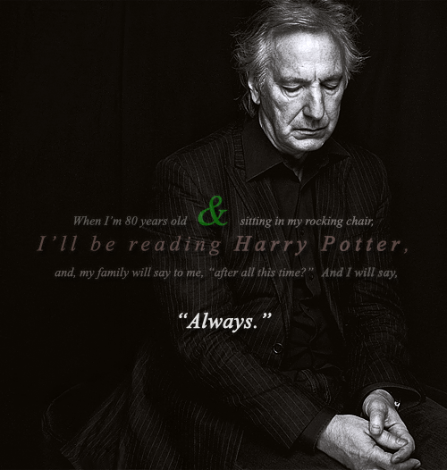
Sniff: Jesus. YES, PLEASE.
PS. Victor just pointed out that I’d included Rickman in my 2009 list of “men we think are incredibly sexy but that our husbands don’t understand”. Also included in that list were Bowie as the Goblin King and Philip Seymour Hoffman. I’m starting to suspect Victor is taking them all out, one by one. Lock your doors and look both ways when crossing the street, Neil Gaiman, Prince and Eddie Izzard. I can’t stand to lose any more of you.
Notes:

#2: Mark Forsyth, The Inky Fool

WEDNESDAY, 7 AUGUST 2013

Hamlet is Banned
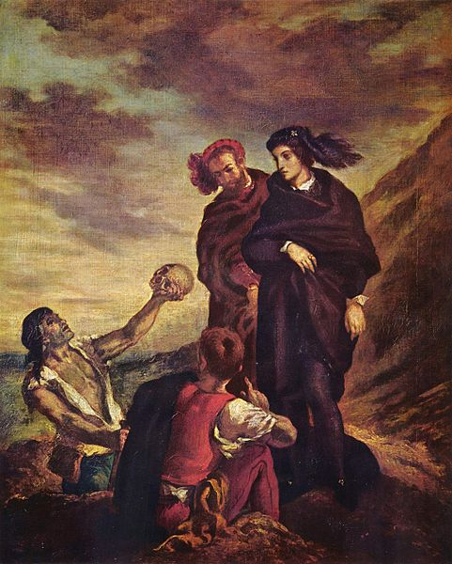
Because of all the attention this post is getting, I ought to point out that I was not intending to disclose some outrageous Orwellian conspiracy, merely incompetence and inertia. I wrote the post because of 1) The amusing absurdity of the greatest work of British literature being blocked by the British Library. 2) The evident silliness of filtering systems, particularly one that blocks mit.edu but not facebook. 3) The frustration of dealing with institutions that disown their own Internet provider. 4) The miserable truth that over the last couple of years the failures of the BL's wifi - whether broken, slow or filtered - has forced researchers to choose, reluctantly, between books and the Internet.
On Monday, I was sitting in the British Library frantically trying to write my new book in a shturmovshchina. I had to quickly check a particular line in Hamlet, so I Googled Hamlet MIT, because the Massachusetts Institute of Technology has put the entire works of Shakespeare up on the Internet. (It takes 70 mins to order a physical book). I clicked on the link and...
A message came up from the British Library telling me that access to site was blocked due to "violent content".
Now, Hamlet is a violent play. I see that. When the curtain comes down there's a lot of bodies on the boards. But...
But...
I tried it again. It told me that my attempts to access this violent content were being logged.
I took my computer over to the information desk, and after I had explained to them what MIT stood for (really), they called the IT department and told them about the webpage that I had been blocked from. http://shakespeare.mit.edu/hamlet/full.html
They had to spell out Shakespeare letter by letter. Really. Ess. Aitch. Ay. Kay...
I asked them if they were surprised that Hamlet was now banned in the British Library. They shrugged. I asked them how it was that I could still access youtube, facebook and twitter. I asked why the girl at the next desk to me had been able to spend the last half hour on Guardian Soulmates, while the Massachusetts Institute of Technology's website was banned. They shrugged.
I asked if they saw the problem, perhaps just the symbolism, of Hamlet being banned in the British Library. They shrugged.
The IT department said there was nothing to be done, as it was only the British Library's wifi service that was blocking Hamlet, and the British Library's wifi service, they seemed sure, had nothing to do with the British Library. They were merely ships that passed in the night. Children crying to each other from either bank of an uncrossable river.
'But,' I said. It's one of those points where you just want somebody to understand the central point. 'The British Library has banned Hamlet for being too violent.'
And the lady behind the desk nodded and smiled.
It's one of those points where I don't know whether they're insane, or if it's me. Maybe Hamlet should be banned. I wrote an angry e-mail, and this morning I got one back saying they're looking into it. But maybe I should give all this up and get a job as a lighthouse keeper. But I fear I'd still have those dreams, those dreams about that man with poison sword and the people fighting in the grave and the venom being poured down my throat. O God! God!
UPDATE: The British Library has just tweeted to say that Hamlet is now unbanned.
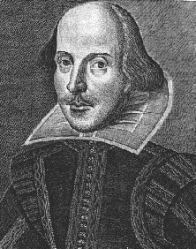

Ess Aitch Ay Kay Eee Ess Pee Eee Ay Ar Eee
Notes:

#3: Allie Brosch, Hyperbole and a Half
We will view this blog on the screen together as a class.
http://hyperboleandahalf.blogspot.com/

Notes:

