Read—in the actual 1984 book—pages 179-185. Stop when you can see the font change a second time and it begins to read, “Chapter 3 WAR IS PEACE.”
Modified Text for “The Book” by Goldstein.
Overview: “The Book” was written by Goldstein and is meant to reveal the truth behind Big Brother’s rule and the way Oceania and the world is organized. It is broken down into three sections with each chapter focused on the slogans of the Party—“War is Peace, Freedom is Slavery, and Ignorance is Strength.” For most of the chapter, Winston reads the book (and skips around) while Julia sleeps beside him. Winston’s reading of “The Book” takes almost 30 pages! Although you won’t be directly reading those pages, consider why Orwell would include “the Book,” and why it is so long.
Modified Text for pages 185-199
While reading the chapter titled, “War is Peace,” Winston learns these facts:
- The world has been broken up into 3 super states, which was going to happened in the 20th century no matter what. Russia absorbed Europe=Eurasia; the UK absorbed the USA=Oceania. See the map below…
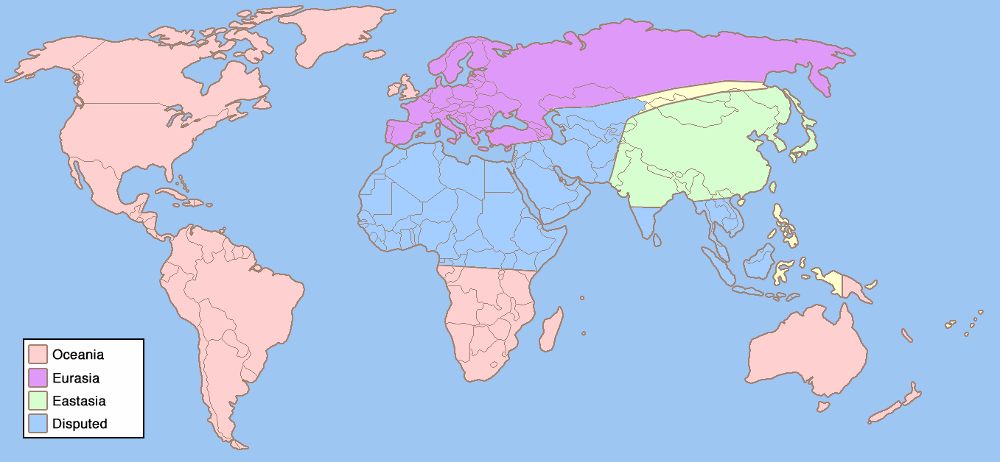
- These states are always “at war” with each other, but in reality there is little actual fighting in battle. No matter what, even if two superpowers join forces, they will never be able to defeat one other. And in reality, they don’t have anything to fight about because they have all have the exact same type of totalitarian government (just with different names) and all the natural resources they need in their own territories.
- The real reason for “war” and telling the people they are at war is to keep people poor, tired, scared and united against the “enemy.”
- Normally, when you are in war, your economy increases because people are working to make goods for the war effort. Normally, people are wealthier in war times. However, in Oceania it is all about keeping people working, tired, and poor, so the government destroys all of these extra goods.
- The book reveals that “the two aims of the Party are to conquer the whole surface of the earth and to extinguish once and for all the possibility of independent thought” (Orwell, 193). And realize, this is not just in Oceania but also the same aims in Eurasia and Eastasia.
- Now there is one way people could destroy each other—with the atomic bomb. However, no one will ever do that because it risks destroy their totalitarian rule and power.
- So, in the end, the war is used to “keep the structure of society intact[ed]”(Orwell, 199) for Big Brother. Thus, War=Peace. It keeps the citizens of Oceania at peace with Big Brother and his dystopian world.
Now go back into your 1984 book and read pages 199-201, where we see the font change back and can read narration about Winston and Julia. On page 201 where it says, “Chapter 1 IGNORANCE IS STRENGTH” you will stop and read the modified text below…
Modified Text 201-217
While reading the chapter titled, “Ignorance is Strength,” Winston learns these facts:
- Society has always been a three class system. In the book it says, for all of time, “there have been three kinds of people in the world, the High, the Middle, and the Low” (Orwell, 201).
- These three classes are constantly conflicting with one another because the High class always wants to be the upper class; the middle class wants to move up and become the upper class; the low class wants to eliminate all of the classes and have everyone be equal. This is a cycle that goes on and on for all of time.
- The book states that “inequality was the price of civilization” (Orwell, 204), so these social classes will always exist and no one will ever have true equality.
- The book also notes that there have been other totalitarian types of government in the past that have failed, but they failed because they didn’t have the technology needed to control their people.
- “In the past no government had the power to keep its citizens under constant surveillance” (Orwell, 205) so rebellions would keep happening and the middle and lower classes would try to rise up. Now they have technology to monitor this.
- The book mentions more ways to prevent rebellion including making sure no one owns anything (like property, houses, etc.), and “the Party owns everything” (Orwell, 206) and making sure the masses never “become aware that they are oppressed”(Orwell, 207)—thus we see censorship and propaganda a lot in this world.
- Another important feature of the government is Big Brother; the book reveals that no one has ever seen Big Brother and he will never die—he is the top of the social pyramid and will always lead the government.
- As far as who is part of the Inner Party, it is not hereditary, nor is it racially biased—so you can’t be born into it, nor rejected for your race or religion. You are picked when you are 16 after an examination. However Proles are never allowed into the Party. Any Prole that seems too smart is vaporized by the Thought Police.
- Party members “lives from birth to death under the eye of the Thought Police” (Orwell, 210).
- They also mention how the past needs to be destroyed to keep people “cut off from the past”(Orwell, 212) and to believe the Party and Big Brother are always right…this is where with see ignorance=strength. The more ignorant your people, the stronger you will be, and the more control you will have.
- The book begins to end with discussion of how past governments like these have failed because they “grew soft” (Orwell, 214) and doublethink (which is thinking two contradictory things at once).

On page 217, finish reading the chapter in the actual 1984 book.

Reactions and Notes:

Part Two Response Prompts (please answer in your writer’s notebook)
- Examine Julia’s belief, “If you kept the small rules you could break the big ones” (Orwell, 129). Do you agree or disagree with this statement? Provide examples to support your answer.
- Evaluate Winston’s belief, “The end was contained in the beginning” (Orwell, 159). Explain and discuss what this means.
- Differentiate Mr. Charrington’s current use of the poem about London’s churches and the previous times when Winston had heard it.
- Describe and explain Orwell’s structure for Part II of this book. Think about chapter IX and Goldstein’s book and its impact on the reading pace and the dramatic turn at the end of Part I.

