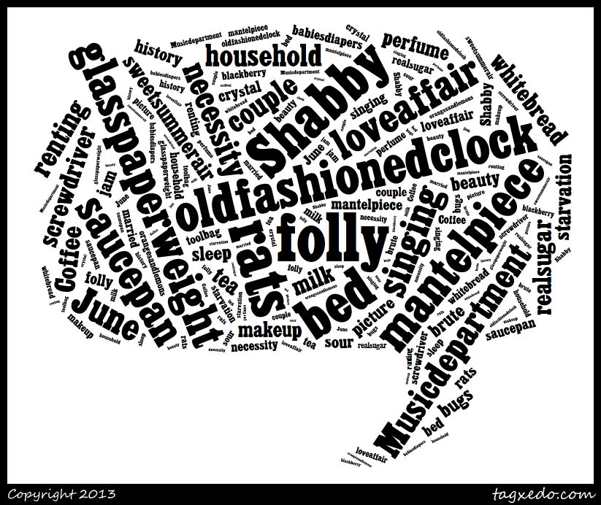

Fears

Love vs. Lust

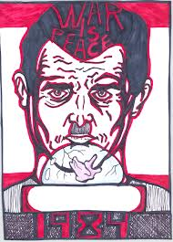

He who sings frightens away his ills.
~Miguel de Cervantes, Don Quixote

The book says, “Folly, folly, folly! He thought again. It was inconceivable that they could frequent this place for more than a few weeks without being caught. But the temptation of having a hiding place that truly was their own, indoors and near at hand, had been too much for the both of them” (Orwell, 138).

