Directions: Read through the text below and highlight good ideas that you like and could use on your own electronic portfolio…

6 Steps To Creating A Knockout Online Portfolio
by Mell Ravenel
To get some insight on what works (and what doesn’t!) when it comes to showcasing creative work online, I chatted with Matias about his observations and extracted six simple tips for building a knockout creative portfolio:

1. Take a step back, and curate your best work.
Take the time to look at all of your work and carefully choose the right pieces for your portfolio. “One piece of advice I got from my mentor was to always showcase the type of work you want to be doing in the future,” says Matias. “Display only the projects that you are really proud of, that look the best, and that use the best materials.” Choose at least five projects so you can demonstrate the breadth of your work, but be selective. Remember, it’s always better to have a portfolio of a few projects that are stunning than dozens of projects where some of them are just OK. The quality of your portfolio is only as good as your weakest project.
Always showcase the type of work you want to be doing in the future.

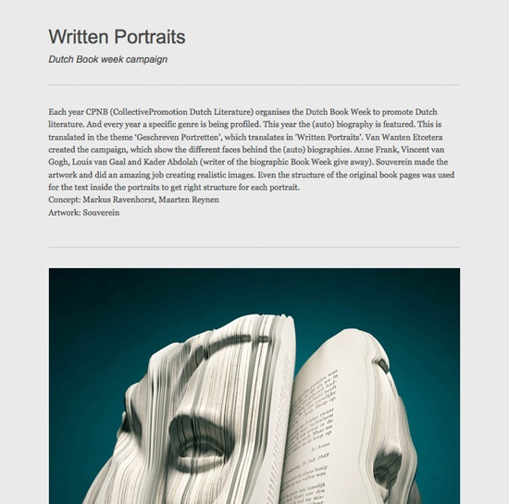
2. Use eye-catching images, and share the backstory.
Now that you’ve edited the work you want to show, get into the nitty-gritty of each project and think about how to best present it. Visitors like to know the story behind your finished work, so think about presenting your process — from the initial concept, to early sketches, to the finished product. A good rule of thumb is to present the whole piece first, followed by more detailed shots to show the precision of your craft. Stylized photography is a nice touch, as long as it doesn’t distract from the work itself.
Matias: “First, contextualize the project with a short paragraph. Add a title that makes sense and gives a hint of what this project is about. You want this to be quick reading — you need to be able to glance at it and understand what it’s about. The title, a short paragraph, and first image should be engaging enough to make people want to look at the entire project.”

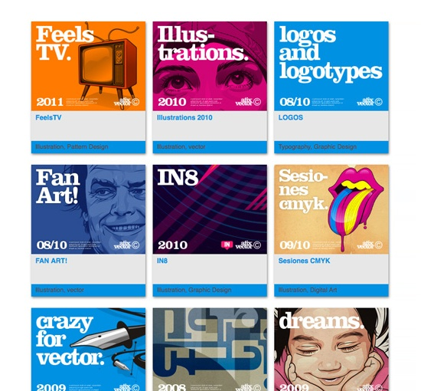
Once you’ve decided how to frame and explain your project, focus on finding the perfect images or media to showcase the project, starting with a cover image.” If you’re using covers to present your projects in a gallery, it’s important that your cover is crafted,” says Matias. “Your cover doesn’t have to be an exact image from inside your project — you can custom design a cover if the project requires it. For example, maybe you just want to display text. Unify the look of your covers as much as possible.”

3. Keep the website design simple, and let the work take centerstage.
When designing a portfolio, you want a website that is straightforward. You want your content to be the focal point, rather than a distracting design.
“Your website is a vehicle for people to find your work,” says Matias. “You don’t want the site to be overly flashy or unconventional — that will make the content more difficult to access. It’s not that I prefer minimalistic designs — it’s a question of creating the visual environment you need to showcase your work most effectively. Simplicity in the interface and visual design of your website will push your work to the surface, where it should be.”
This means simple navigation and the fewest amount of website sections necessary. “Have a gallery of work and a contact page? That’s a great portfolio website.”
Simplicity in the interface and visual design of your website will push your work to the surface, where it should be.
When it comes to customization, Matias advises you to keep it simple —pick one font, and keep things consistent. “One font and sticking to it will make your life easier. Pick a color for each link state that’s the same across the site.”

4. Craft a bio that expresses your unique process and/or point of view.
Personalize your “about” page to tell your story, not just list your past jobs. Here are a few key pointers for reinventing your resume as a compelling bio:
- Share a Point of View. As a creative, you have your own unique perspective on your industry and the creative world. Frame your bio with your own creative focus or mission statement.
- Create an origin story. Share the backstory of how you developed your point of view. Did you have an experience as a kid or early in your career that lead you to pursue a passion or shaped your creative direction?
- Ground your experience using external details. Anchor your bio with details that demonstrate your connections through the creative world. Think notable clients, press, or publications.
- Be approachable. Round your story out with some personal trivia. Have any hobbies or interests you obsess about? Revealing some guilty pleasures keeps your bio approachable and relatable.
Personalize your “about” page to tell your story, not just list your past jobs.

5. Add distinctive elements (e.g. awards, your blog), and broadcast your work.
Now that you’ve got all of the necessities, consider any other distinctive elements that you can include to give you an edge.
- Mention awards. If you have mentions in press or awards, do include them.
- Invite contact. If you’re looking for freelance or contract work, consider using a contact form on your portfolio. Forms from Wufoo or JotForm allow you to customize fields so you can ask for all the information you need up front, like budget and timeline expectations.
- Make sharing easy. Including buttons to share your work on social media (e.g. Twitter, Facebook, Google+) can help bring more exposure and an audience to your site. Promote your work on social media whenever you add new projects to draw attention to fresh work as well as your overall portfolio.
- Include your blog. If you do have a blog that you update frequently that also represents where you are professionally or adds value to who you are, include it. Matias advises, “A blog needs to add something to your site – otherwise forget about it. No clutter.”

6. Keep your portfolio fresh.
Keep in mind that your work doesn’t end with just creating a killer portfolio. You’ll also want to regularly update it. The best portfolios are never static. As you create new and better work, make sure you make additions to showcase your latest projects, but with the same focus on careful curation!

Final Reflections:
What are some good ideas from this text that you will try on your own electronic/online portfolio?

