Sometimes pushing away from the traditional format for a short story, narrative, or novel can really show creativity and help you better express your theme or lesson. Below is a list of several “non-traditional” genres, but can you think of any others?

- Recipe
- Personal Ad
- Greeting Card
- Letter
- Play
- Magazine
- Picture Book
- “How to”
- Invitation,
- Comic Strip
- Obituary
- Newspaper
- Poem
- What else:

Traditional:
My dog Edgar is turning one years old this month. He is no longer a puppy, and I can’t call him my baby anymore because he has gotten so big. I remember when he was so small I could hold him in my arms. He was so chubby and short—he was rotund little fellow. I am amazed how big he has gotten in twelve short months. His fur has grown long, he has gained a greedy 40 pounds, and mellow out—sort of. He is part of the family and no matter what he has done: torn up shoes, ran off with my school papers, or terrorized the cat; I still can’t help but love him.
Non-Traditional:
WANTED
One medium build, 50 pound mutt—a mix of lab, sheepdog, and chow. He goes by the name: Edgar, Eddie, Bubba, and ED-GAR! He is black with a heavy, curly coat of dark ebony and dark chocolate eyes that will melt your heart. Don’t be fooled. He is sneaky, cunning, and has ulterior motives that usually involve food. He is now a year old and is moving out of his puppy stage, but will still try to tackle a cat if you aren’t looking and chew up papers that are left on the table. Approach him carefully because he may think you are playing a game of tag. When you find him, please call his owner at: Can’t-help-but-love him.
How to train an Edgar
- Food is the best bribery tool.
When in doubt, go to a food source. If he is running away from you, bring out food. If he is wrestling with the cat, bring out food. If he is chewing on something—the cat or otherwise—food. The best options are lunch meat or cheese. These products come in small sizes and are easy to clean up. Peanut butter is also a strong selection due to its intoxicating smell, albeit messy.

The recipe for the perfect dog.
ESATICALLY ENJOYABLE EDGAR RECIPE
You will need all of the following ingredients to make the most adorable dog on the face of this earth.
Main ingredients:
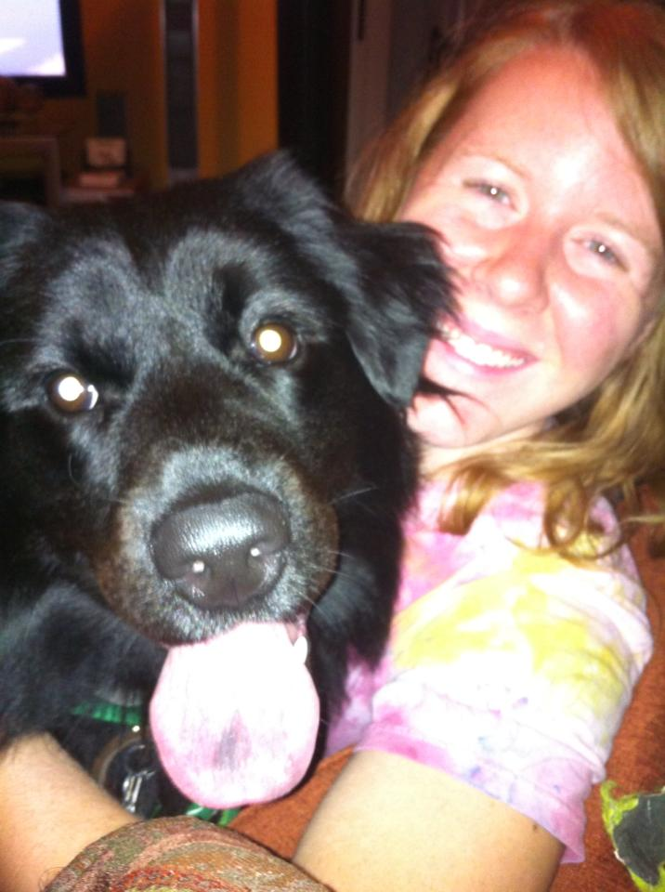
- Thick, curly black hair—that will shed anywhere AND everywhere, ALL OF THE TIME.
- A round, hearty belly
- A goofy grin
- A long purple spotted tongue
- Dark, intuitive brown eyes
To really add personality to the mixture you must also include:
- Lots and lots of love and attention
- Spoiled rotten treats like pig ears, peanut butter, and raw-hides
- Moments of chasing the cat, and barking incessantly at the squirrels outside the window.

Over time, as all of these ingredients come together you will have a new family member you can’t live without. He will adore you. Smile at you. Cheer you up, and make you laugh. He will drive you crazy, and test your patience. However, he will love you for years.

Serves: John, Ruty, and Amber Rutan, and occasionally Debers.

Ideas/Reflections:

