Rutan’s
POETIC SOUNDS AND STRUCTURES

First Edition
Amber Rutan.
English Extraordinaire.

A poet is, before anything else, a person who is passionately in love with language.
-W. H. Auden

Dedicated to Edgar, my puppy…

Brief Contents
Foreword -------------------------------------------------------------------------------4
Narrative Poems
“Furrow On My Brown”-------------------------------------------------------------5
“The Book Fight”----------------------------------------------------------------------6
Critique on Human Nature Poem
“Humanity You Aggravate Me”----------------------------------------------------7
Nature Poems
“Give Me Style”-----------------------------------------------------------------------8
“The Green”---------------------------------------------------------------------------9
Poems for further reading
“The Wave”---------------------------------------------------------------------------10

Professional Acknowledgements
- “Mirror” by Sylvia Plath

-This poem inspired my poem entitled, “The furrow on my brow”

- “Humanity i love you” by e.e. cummings
-This poem’s format is mimicked in my poem entitled, “Humanity you aggravate me…”

- “The White” by Patricia Hampl
-This poem’s format was mimicked in my poem entitled, “The Green”

Foreword:

Dear Readers,

I have struggled with writing creatively. So much of our world is uncreative—unoriginal, poorly thought-out, and designed. Have you seen what is on TV lately? Have you read the news?

This anthology is my experimentation with creative writing—especially poetry. I have draw from my own personal experiences and been inspired by some of our most insightful poetic writers. Sylvia Plath, e.e cummings, and Edgar Allan Poe have shown me wonderful voice and description, and I want to emulate that my own writing.

I am not going to show any more in this sample because I don’t want to steal any of your own ideas, but this foreword should discuss what poetry is to you. What have you learned about poetry? How has it helped you with creative writing? What poems and lessons will stay with you for the rest of our semester? Give advice and celebrate what you have learned! You need to use this foreword page to share and it should be in a letter format.

So, enjoy my sample anthology and I hope it inspires you, intrigues you, and captures your attention.

Sincerely,
Mrs. Rutan

The furrow on my brow
By Mrs. Rutan

I can see the wrinkles.
They fold and pucker everywhere, anywhere like piles of laundry, or stacks of paper.
I’m 26,
only 26
and
They sneer and snicker and smirk, again and again.
They always pop up at the worst moments
these wrinkles.
A picture,
A photograph.
A mirror.
Why do they mock me so?
A well needed laugh and there they are again—crinkled at the edges of my bright eyes.
A laugh I cut short when I realize they are creasing
on my face.
They have made their nasty appearance.

Then,
I think, they show with laughter, smiles and grins; they
show love, excitement, and joy.
A reminder of a good life,
a great life.
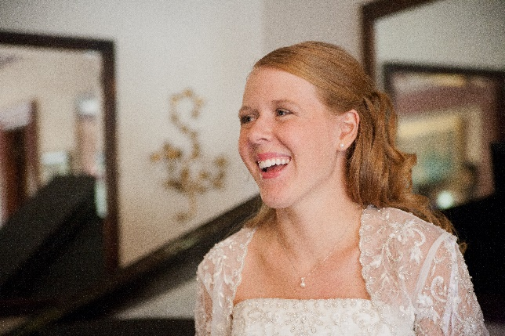

And hey, I’m only 26.

wrinkles wrinkles wrinkles wrinkles wrinkles wrinkles wrinkles Wrinkles wrinkles wrinkles wrinkles wrinkles

The Book Fight

Don’t judge.
I mean it.
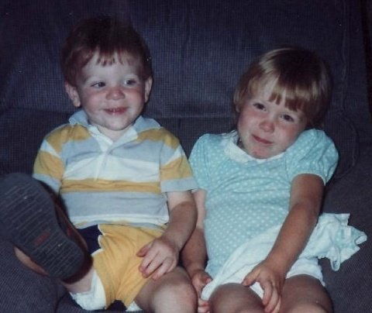
My brother and I were having a book fight.
Yup.
Hard cover books.
Our favorite books too: Mickey Mouse and Dr. Seuss.
They sailed across huge pillow forts and blankets.
Most of the books carelessly bounced off the cushions.
My brother and I burst into fits of giggles.
Again and again.
Invincible and untouchable.
Just the two of us.

Then my brother threw good. Hard. Precise.
Right above the eye.

My eye.

It was the edge of the book—hard cardboard.
It slit with the same precision and damage of a steak-knife.

The blood came out like a geyser and so did the tears.
“I’msorryI’msorryI’msorry!!” he cried out.
He said it for days.

I will never forget that day: the stitches, the ER, the glory.
That was a day with my brother.
A day of our youth.
A memory of foolish, but wonderful adventure;
A day where stitches weren’t the worst thing that could happen between siblings.

It is easy to forget memories like this, but I mean it.
Don’t judge.
You didn’t know him.

Humanity You Aggravate Me
By Mrs. Rutan (with help from the 2013 Creative Writing class)

Humanity you aggravate me because you are so
Distracted and uncouth.

You are rude.
Rude when you walk.
Rude when you talk.
R-u-d-e.
Where are your manners?
Remember words like

Please,
Thank You,
And Excuse me?

Here I am—hungry, tired, and politely anticipating
My ambrosial sandwich.
Then it begins.
Screaming children are running around like the shop
Like it is their own personal playground
where chairs become slides, the chip cart becomes a merry-go-round;
they invade my personal space, my protective bubble
and their parents are oblivious
to their zoo like behavior.

I wait quietly, patiently.

Their parents chat it up with the customer beside them
Loudly.

Order? The subway girl asks.
Talk-talking-talk-talk-talking-stilltalking-andthentalkingsome more.

Order?! The subway girl pleads.
The children shriek.

I watch it all quietly, but my patience is almost gone.

Humanity you aggregate me.
Always so rude—adult and child alike.
Where are your manners?

Who knows.
Give me style
Taken from “New Perspective” on 1-30-13

Many call me a majestic beauty.
An old world beauty.
Icy blue waters and white edges and thousands of gallons of water.
Throwing over a steep cliff for centuries.
The rocks below me groan and cry—they fall to the bottom.
Some float downstream, some remain below.
Continuously hit by water.
I am pretty old.
So old, and so—boring.

But I love the night!
My favorite time!
When the sky fades to a rich, dark, and promising black.
I love the night and the light show that illuminates my waters and gives me—what’s the word—style.

Style.
I am pretty old, but when the lights turn on, oh the lights!

I have watched humanity around me, and seen how they have built new beauty.
Steel grays, fluorescent lights.
Have you seen the Hard Rock café?
I can’t compare to colors like that!
At least not during the day.
So I love the night.
Illuminate my waters!
Give me style!

The Green
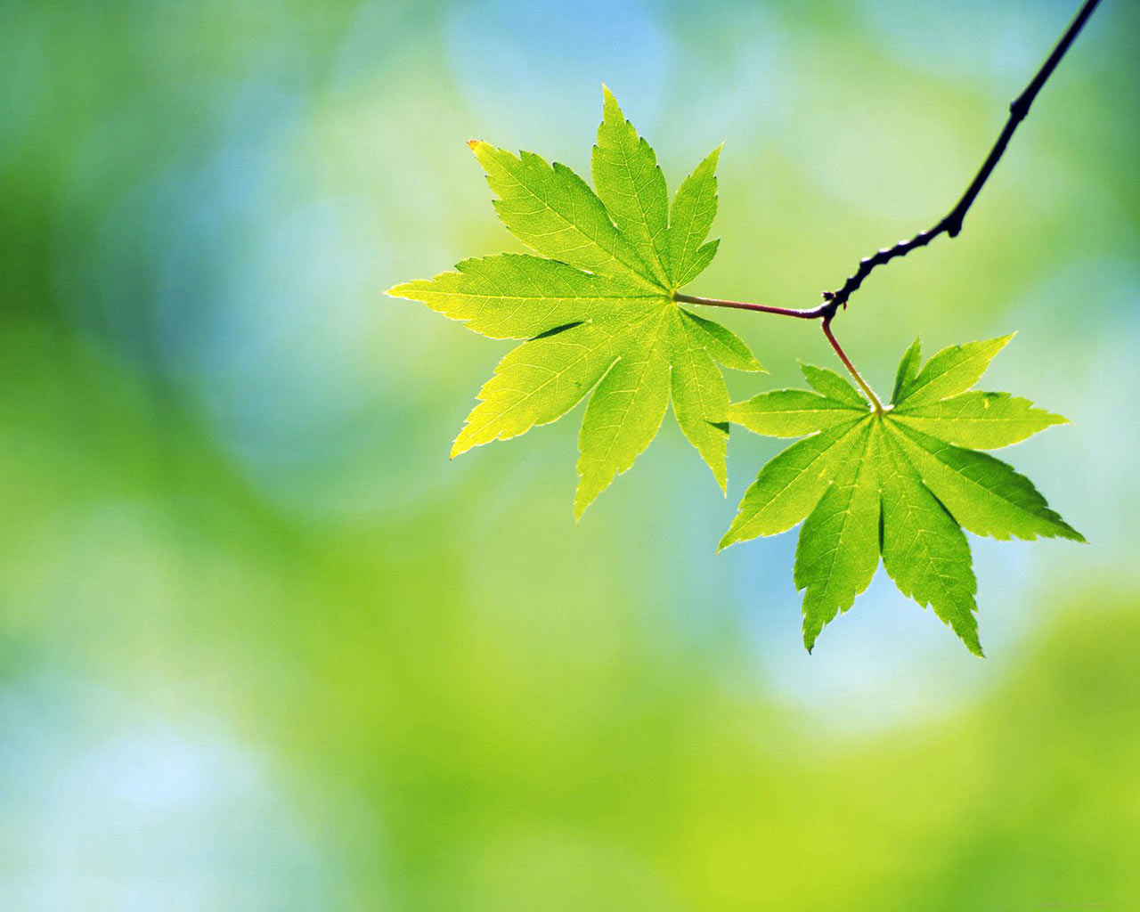

It is when the snow—the clean white snow—has melted,
And the Earth turns to mud.
Thick.
Brown.
Mud.

I hate the mud. The way it
Hemorrhages beneath your clean work shoes.
The brown bleeds on your heels and kicks up on your pants.
The brown is everywhere.

I look at the dingy bogs and wish for the green.
Lime green, rich green, forest green, neon green.
Green like limes,
Or emeralds.
The green of new life.
It is when the green explodes on the tree tops and sprouts from the ground. It no longer hides or tries to stay contained.
It is free.

No more brown muck.
No more ugly sludge.

A new Green day.
A fresh new slate.
Spring.

Poems for further reading:
The Wave
Taken from, “Japan—Earthquake, Tsunami and Nuclear Crisis (2011)”
New York Times: March, 29, 2012
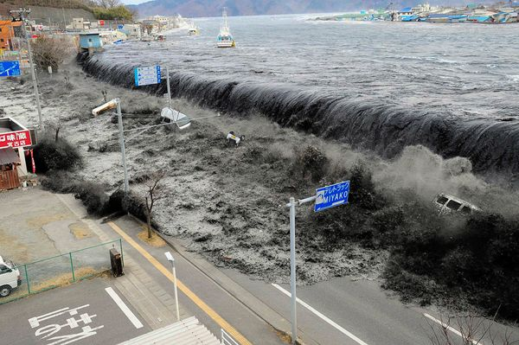
Japan is still reeling.
Actual Article: In many ways, Japan is still reeling from the devastating earthquake and tsunami of March 11, 2011, and the nuclear crisis and huge leaks of radiation it set off.
The earthquake and tsunami, which killed as many as 20,000 people, led to soul searching in a nation already worn down by two lost decades of economic growth, a rapidly aging and now shrinking population, political paralysis and the rapid rise of its longtime rival, China.
When the earthquake struck off the coast of Japan, it churned up a devastating tsunami that swept over cities and farmland in the northern part of the country and prompted warnings as far away as the West Coast of the United States and South America. Recorded at 9.0 on the Richter scale, it was the most powerful quake ever to hit the country.
As the nation struggled with a rescue effort, it also faced the worst nuclear emergency since Chernobyl. Explosions and leaks of radioactive gas took place in three reactors at the Fukushima Daiichi Nuclear Power Station that suffered partial meltdowns, while spent fuel rods at another reactor overheated and caught fire, releasing radioactive material directly into the atmosphere…

Soul searching, worn down
Devastating.

As many as 20,000 people.

It struck off the coast of Japan.
It swept over cities—
Prompted warnings.
Most powerful to ever hit the country.
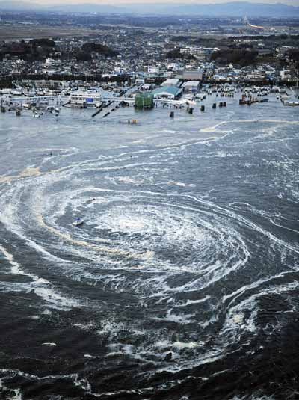

As many as 20,000 people
Japan is still reeling
It churned up
Struggle
Explosions
Leaks
Radioactive Gas
Nuclear Emergency
Farmland
Japan is already on the road to recovery

But

As many as 20,000 people
Killed.

