Look at one of my first drafts and compare it to my final polished draft—how did it change?
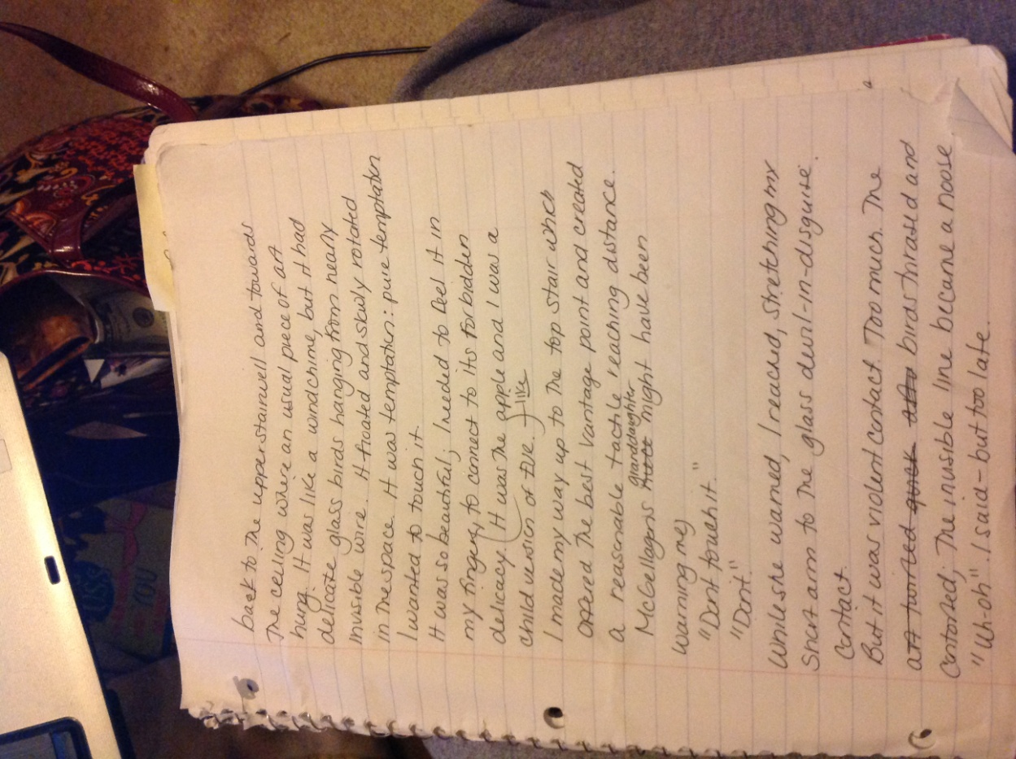

A CHILD’S CONTRITION
By Amber Rutan

The house was a glittering enigma; as a small child, you don’t realize how much your perspective—your small eyes and short stature—can exaggerate things, but this home was an intriguing colossus. It was a handsome two story, very rectangular, with white trimmings here and there to help add dimension to the deep red bricks that made up its exterior. It was the only house on the street that was perched on a slight embankment, which added to its grandeur.
I thought the older couple—the Magellans—were royalty, or at the very least incredibly wealthy. Little was known about them. They seemed to avoid going outdoors, and when they did, they always wore heinous sweaters, even in the harsh July sun. They were—well, old. And old people got grumpy, so I stayed away from them as best I could, but I couldn’t stay away from that house for long.
There were rumors of what was on the inside.
“A library that mirrored the one that the beast gave Bell in the Disney classic!” whispered one neighborhood child.
“…A vault with a hoard of jewels and gold,” challenged another.
It was all speculation of course, but one piece of gossip we knew to be true—the elevator.
“An EL-la-vay-tore.” The word echoed beautifully on our inexperienced lips. I could feel it roll off my tongue like a piece of silky chocolate or a cool ice cream bar. For a kid whose balancing skills were subpar at best, and who had to walk up a grueling thirty-two stairs everyday to get from the basement to the kitchen to the bedrooms, an elevator was a sure sign of royalty.
I heard this from a kid, who knew a kid, who knew a kid who had seen it, so naturally it was true.
It was the mystery that teased me every summer of my childhood. I had to get inside to see that coveted treasure for myself.
I distinctly remembered one hazy summer playing with Old Mrs. Magellan’s granddaughter from time to time. I don’t remember her granddaughter’s name, but she seemed to be fun, or maybe she was just a pawn for me to get inside that house and see that elevator.
One day, we went to play in the backyard that was well shaded by a slew of ancient maple trees, and explored an oddly-modern glass back porch. It was hideous. The windows were like clear shutters, but made of clear glass; the door was an ugly old metal thing that creaked awfully when you went inside, and the porch has two distinct stairwells. When you shut the door behind you, you looked up to see one set of dark stones leading up to the backdoor of the house, while the other shorter set led to an ominous black, shadowy door. It was alluring, but terrifying—a no go for me.
My attention turned back to the upper stairwell towards the ceiling, where something winked at me. I squinted back. It was a usual piece of art dangle from the ceiling. It was like a wind chime, but it had a collection of delicate glass birds hanging from a nearly invisible set of wires. The sunlight bounced off the avian creatures, scattering beautiful glints of violet, orange, and yellow around the porch; spots faded in and out on the floor and the walls. It floated soundlessly and slowly rotated in the space like a dance. It was tangible temptation: pure temptation.
I had to touch it.
It was so beautiful; I needed to feel its beauty in my fingers, to connect to its forbidden fragility. It was the apple, and I was the child version of Eve.
I made my way up to the top stair, which offered the best vantage point, and created a reasonable tactile reaching distance.
Magellan’s daughter might have been warning me:
“Don’t touch it”
“Don’t…”
While she chirped in the background, I reach out in front of me; I stretched my short arm, seeing the colored shadows jump and kiss my raw skin. I stretched as best I could towards the glass devil in disguise.
Contact.
But I was too zealous. It was violent contact. Too much. The birds thrashed and contorted, they spun around destructively, the invisible line became their noose.
“Uh-oh,” I whispered—but it was too late.
The beautiful piece of art was a convoluted mess and before I could reach again to amend myself, Old Lady Magellan burst in from the door, nearly knocking me down the stone stairwell.
“Ohhh-ohh! “She howled.
“Look! Look what you have done. Look what you have DONE!” She bellowed even louder. She had to have been watching me. I should have known; old people had better sight than we give them credit for. I felt shame all over me and my face flush red.
Her granddaughter remained a silent witness behind me. I was too shocked to do anything. I couldn’t run. I didn’t want to say anything back to her; prior experience told me that doing that just evokes more yelling from said adult.
Her face was a brilliant shade of purple, a stark contrast to her white, wiry hair. Her wrinkling and spotted face scared me. I had never seen her so up close before. She was a troll. A very short, but very angry troll.
“Go home.” She said, looking up at the destruction.
“Now.” Her eyes then bore down on me.
She didn’t have to tell me twice. I scampered down the dark, grey stairwell in a flash. My heart pounded until I was out of Magellan territory and in the safety of the sunny sidewalk in front of the Flees’ house.
I tried to walk normal, letting the adrenaline seep out of my pores. I almost just died! I thought to myself. I touched my arms and legs, thankful to be alive. Then, I came to a somber realization of what I had just done.
Images of the frenetic, contorted birds flicked in and out of my memory.
I reflected to myself mournfully—guilty.
Now, I knew for certain.
I would never be able to go back to the Magellan house ever again. I shook my head and let my hands drop dolefully to my side.
I sighed.
The consequences of my actions were deep, irreversible, and felt heavy on my conscience.
I knew.
I would never, ever see that elevator.

After reading, answer these questions:
- How did I start my story? What was my lead?

- How many paragraphs is my overall story? What do you notice about my organization?

- What are three things I did that you are going to try in your own narrative?

- Activity: Circle all of my exciting verbs (action words).
- Activity: Highlight the moments were I really “explode the moment” or had strong imagery.

