 | 1860s (The Civil War) | 1910s (WWI) | 1940s (WWII) | Observations
1.  Hair Styles | 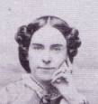 | 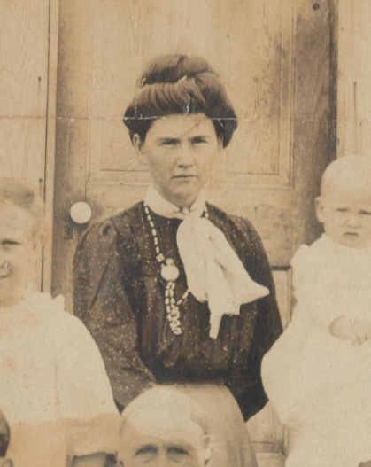 | 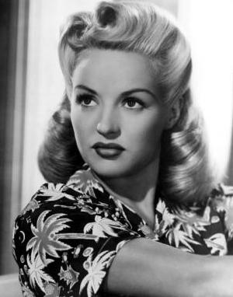 | --1860s hair was pretty stern—with a harsh part in the center and perfect symmetry, which may be a reflection of the time: women needed to be presentable, clean, and orderly.  -- It is interesting how the hair changes to looser “top-knotch” look in 1910, with a bun on the top of the head. The hair looks like its more about function: its up, out of the way, and looks quickly done.  --1940s hair shows more beauty and sensuality. The hair is curled and partly down—which is very different than the decade before. Women seem more into style and beauty and even though each era faced war, there may have been less stress and obstacles in 1940s America than in the 1860s or 1910s, so women could play around more with their hair styles more.
Hair Styles Citations:
Picture #1: http://media-cache-ak0.pinimg.com/236x/05/a0/e5/05a0e5249d5c6af23c1595bfe4c7f570.jpg
Picture #2: https://s3.amazonaws.com/socialserendip.com/other-close1.jpg
Picture #3: http://www.myvintage.co.uk/user/1940s-hairstyles.jpg

