Death Marches
Directions: Read and annotate the text!
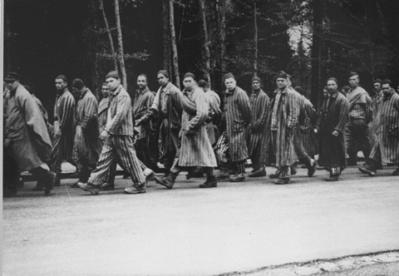
Prisoners head south on a death march from the Dachau concentration camp. Gruenwald, Germany, April 29, 1945.
— KZ Gedenkstaette Dachau
Near the end of the war, when Germany's military force was collapsing, the Allied armies closed in on the Nazi concentration camps. The Soviets approached from the east, and the British, French, and Americans from the west. The Germans began frantically to move the prisoners out of the camps near the front and take them to be used as forced laborers in camps inside Germany. Prisoners were first taken by train and then by foot on "death marches," as they became known.
Prisoners were forced to march long distances in bitter cold, with little or no food, water, or rest. Those who could not keep up were shot. The largest death marches took place in the winter of 1944-1945, when the Soviet army began its liberation of Poland. Nine days before the Soviets arrived at Auschwitz, the Germans marched tens of thousands of prisoners out of the camp toward Wodzislaw, a town thirty-five miles away, where they were put on freight trains to other camps. About one in four died on the way.
The Nazis often killed large groups of prisoners before, during, or after marches. During one march, 7,000 Jewish prisoners, 6,000 of them women, were moved from camps in the Danzig region bordered on the north by the Baltic Sea. On the ten-day march, 700 were murdered. Those still alive when the marchers reached the shores of the sea were driven into the water and shot.

Key Dates
JANUARY 18, 1945
DEATH MARCHES FROM THE AUSCHWITZ CAMP SYSTEM BEGIN
The SS begins evacuating Auschwitz and its satellite camps. Nearly 60,000 prisoners are forced on death marches from the Auschwitz camp system. Thousands are killed in the days before the death march. Tens of thousands of prisoners, mostly Jews, are forced to march to the city of Wodzislaw in the western part of Upper Silesia. SS guards shoot anyone who falls behind or cannot continue. More than 15,000 die during the death marches from Auschwitz. In Wodzislaw, the prisoners are put on unheated freight trains and deported to concentration camps in Germany, particularly to Flossenbuerg, Sachsenhausen, Gross-Rosen, Buchenwald, Dachau, and Mauthausen. On January 27, 1945, the Soviet army enters Auschwitz and liberates the few remaining prisoners.
JANUARY 25, 1945
THE EVACUATION AND DEATH MARCH FROM STUTTHOF CONCENTRATION CAMP
The evacuation of nearly 50,000 prisoners, the overwhelming majority of them Jews, begins from the Stutthof camp system in northern Poland. About 5,000 prisoners from Stutthof subcamps are marched to the Baltic Sea coast, forced into the water, and machine gunned. Other prisoners are put on a death march to Lauenburg in eastern Germany, where they are cut off by advancing Soviet forces. The Germans force the prisoners back to Stutthof. Marching in severe winter conditions and treated brutally by SS guards, thousands die during the death march. In late April 1945, the remaining prisoners are removed from Stutthof by sea, since Stutthof is completely encircled by Soviet forces. Again, hundreds of prisoners are forced into the sea and shot. Over 25,000 prisoners, one out of two, die during the evacuation from Stutthof. Soviet forces enter Stutthof on May 9, 1945.
APRIL 7, 1945
DEATH MARCH FROM BUCHENWALD CONCENTRATION CAMP
As American forces approach, the Nazis begin a mass evacuation of prisoners from the Buchenwald concentration camp and its subcamps. Almost 30,000 prisoners are forced on death marches away from the advancing American forces. About a third of these prisoners die during the marches. On April 11, 1945, the surviving prisoners take control of the camp, shortly before American forces enter on the same day.
APRIL 26, 1945
DEATH MARCH FROM DACHAU CONCENTRATION CAMP
Just three days before the liberation of the Dachau camp, the SS forces about 7,000 prisoners on a death march from Dachau south to Tegernsee. During the six-day death march, anyone who cannot keep up or continue is shot. Many others die of exposure, hunger, or exhaustion. American forces liberate the Dachau concentration camp on April 29, 1945. In early May 1945, American troops liberate the surviving prisoners from the death march to Tegernsee.
http://www.ushmm.org/outreach/en/article.php?ModuleId=10007734

