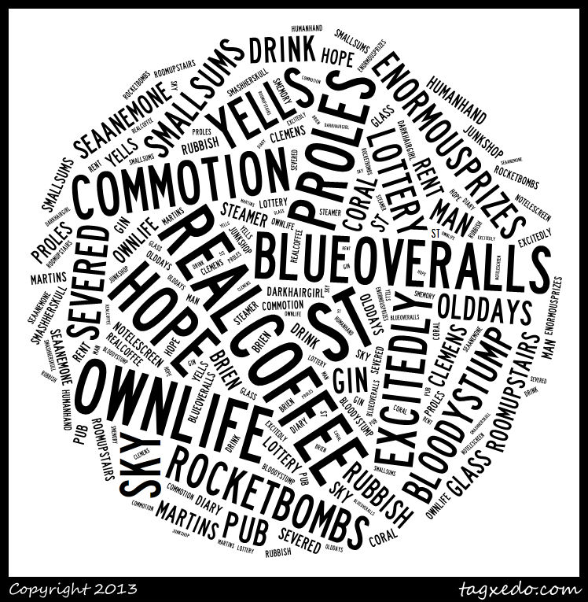

*Chapter VIII Notes…*

*What do you think this chapter is going to be about? Study and discuss the wordle…*