Mentor Text: We will read the picture book, When I was Little, by Jamie Lee Curtis, and use it as inspiration for writing about our own childhood…
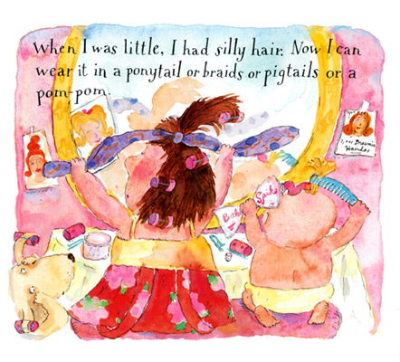
Directions: Read the sentences below and tell me what you notice about them grammatically and structurally (don’t focus so much on meaning).
- Unless I finished my entire dinner, my parents wouldn’t let me play outside with my neighbors.
- Since I had three other siblings, I always had someone I could talk to, make fun of, or harass.
- Because children are ignorant about a lot of things, I often wish I could go back to being young again.

- What are you noticing about each of these sentences—give me 3 observations…

- What are some rules/grammar techniques we have learned—make a list…

Independent Clause | Dependent Clause
Practice: Which of the following sentences are independent clauses? Which of the following sentences are dependent clauses?
- Label them.
- Fix them if necessary.

  - While my mom made dinner

  - Before I saw the book fly towards my face

  - I was a wild child

  - If you have ever eaten a hot pepper

  - It was funny

Grammar Notes—

Revised Passage: After grammar notes and practice…Look back at what you did in your writer’s notebook (“When I was little” free write) and revise it to include least three AAAWWWUBBIS phrases. When you have made your changes, rewrite your passage below…Highlight/Circle the AAAWWWUUBBIS phrases and remember your commas!
4=Awesome | 3=Got It! | 2=Almost | 1=Not Quite
The writer writes thoughtfully and creatively. They go above and beyond with their grammar (10pts)  The writer clearly identifies grammar (5pts)  The writer offers a strong and well detailed list of rules about the grammar technique (1opts) | The writer writes appropriately and completes all of the necessary grammar techniques (8pts)  ___  The writer offers a solid list of rules about the grammar technique (8pts) | The writer may not have a complete write, or its limited on creativity, or they used the grammar technique inappropriately (6-7pts)  The writer vaguely identifies their grammar (3pts)  The writer offers a basic list of rules about the grammar technique(6-7pts) | The writer shows little if any creative writing and/or understanding of the grammar technique (0-5pts)  The writer does not identify their grammar(0pts)  The writer fails to offer and list, or has incorrectly identified the rules about the grammar technique(0-5pts)
______________________________________________________________________________________________________________________________________________________________________________________________________________________________________________________________________________________________________________________________________________________________________________________________________________________________________________________________________________________________________________________________________________________________________________________________________________________________________________________________________________________________________________________________________________________________________________________________________________________________________________________________________________________________________________________________________________________________________________________________________________________________________________________________________________________________________________________________________________________________________________________________________________________________________________________________________________________________________________________________________________________________________________________________________________________________________________________________________________________________________________________________________________________________________________________________________________________________________________________________________________________________________________________________________________________________________________
____________________________________________________________________________________________________________________________________________________________________________________________________________________________________________________________________________________________________________________________________________________________________________________________________________________________________________________________________________________________________________________________________________________________________________________________________________________________________________________________________________________________________________________________________________________________________________________________________________________________________________________________________________________________________________________________________________________________________________________________________________________________________________________________________________________________________________________________________________________________________________________________________________________________________________________________________________________________________________________________________________________________________________________________________________________________________________________________________________________________________________________________________________________________________________________________________________________________________________________________________________________
Reflection: Restate the AAAWWWUBBIS rules and what you know now about AAAWWWUBBIS.
What did you learn today? You may use a bulleted list. See Rubric below.
____________________________________________________________________________________________________________________________________________________________________________________________________________________________________________________________________________________________________________________________________________________________________________________________________________________________________________________________________________________________________________________________________________________________________________________________________________________________________________________________________________________________________________________________________________________________________________________________________________________________________________________________________________________________________________________________________

