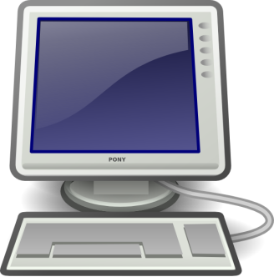
- Essential Questions:
- What purposes, arguments, and messages do authors create in their literary works?
- How can you utilize digital links, video, graphics, and images to enhance your arguments?
- What is the difference between a “required” and “optional” link?
- How do continue to correctly cite your sources, including those from the web, using MLA formatting?

- “Author’s Argument” Essay
Students will revisit the works of Charlotte Gilman Perkin, Margaret Atwood, or Henrik Ibsen to analyze and present an argument(s) they think the author is creating, specifically, with their writing. Students will need to consider WHY the author created what they did. Students can consider arguments in terms of: religion, identity, family, friendship, gender, psychology, etc. Students will explore how they can enhance their arguments through the digital essay format by incorporating different digital sources within their writing.
- The Process: Students will complete at least three drafts. The second draft will be revised with help from conferencing with the teacher. Students will submit a digital final (3nd) draft with revisions based on their conference and in class workshop time (C3, C5, C6, C7).
What is a digital essay?
It can be defined as “a digital essay—a piece of writing meant to be read on the screen rather than on the page” (Harris).
Digital essays allow you to “incorporate into your paper, where appropriate, hot links, images, video or graphics. These should be incorporated into the paper, not tacked on or serving no evident purpose other than satisfying the requirements of this assignment” (Hicks, 51).
The digital essay allows students to “employ the craft of digital writing to meet the purpose of accentuating their arguments as well as to make their essays aesthetically pleasing” (Hicks, 55).

Mentor Texts and Resources:

http://www.nytimes.com/projects/2012/snow-fall/#/?part=tunnel-creek
http://sites.duke.edu/english211s_01_s2013/digital-essay-2/
http://hcapliterature.wikispaces.com/Digital+Essay

Works Cited:
Harris, Joseph . "Digital Essay." English 211s: Digital Writing. WordPress, 2013. Web. 26 June 2013. <http://sites.duke.edu/english211s_01_s2013/digital-essay-2/>.

Hicks, Troy. Crafting Digital Writing. Portsmouth, NH: Heinemann, 2013. Print.

Kelly. Computer Screen and Keyboard Clip Art. 2002. Clker.com. Web. 26 June 2013.

