- What it is…
The most important thing in this class, for this entire semester, is your writer’s notebooks. Writer’s notebooks should be a composition notebook where you will write, write, and then write some more based on our daily readings and discussion.
- Why do I use it?
Writer’s notebooks are more than a journal or a daily record of what you did for that day. These notebooks will house your first drafts, and sometimes even your second and third (revised, not just edited) writings. These notebooks are crucial. So crucial you can expect to use them EVERYDAY. These writings will help build up your stamina, as well as help you explore and be more creative about your writings’ context and craft. Ultimately these notebooks will show your growth and invention as a novice writer from the start of the semester until the very end.
- How do I use it?
Writer’s notebooks are a resource for YOU, and should serve as inspiration for you to record observations as well as revise, polish, and submit quality papers for assessment. If you have a selection in your writer’s notebook worth developing, you can take that 1st write and work on it during our workshops in order to make it into a more formal draft worthy of grading.
- So, what’s my grade?
Writer’s notebooks are subject to grading in many ways—for instance I might grade a final draft from one of your entries, the overall notebook, or a specific date-entry. It is vital that you show effort and maintenance in your notebooks everyday and with every entry; otherwise, your class grade will suffer.
- Disclaimer…
Writer’s notebooks will be viewed and checked by myself and are subject to be shared if there is a concern. Realize…I do, and will read what you are writing, so if there are things you wrote that needs to be reviewed by another adult—to ensure safety, health, and security for you or others—it might be viewed beyond my classroom.

How to Set It Up:

- Leave your first page—your “fly page”—blank.
- Then, Number the rest of your pages. Write only the right hand side, front pages only.
- Later on, only write on the right-hand pages, and keep the left hand pages blank for experimentation and revision.

- Tab and Label the following pages:
  - Section One…………………………Writing (no label needed, pages 1-79)
  - Section Two………………………………Mini-Rulebook (pages 80-98)

- Decorate your inside cover for inspiration—see my sample below!

General Rules:
- Never, ever tear out pages from your writer’s notebook. If you feel the need, see me!
- Keep these notebooks safe. If you need to, you can store them in my classroom.

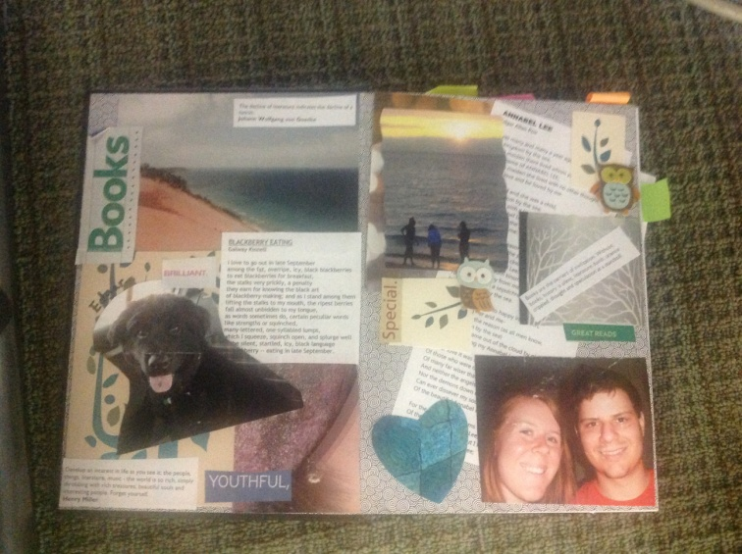
- Homework:
- You need to bring in a writer’s notebook.

- You will also find some personal pictures, quotes, and visuals to paste and collage in your writer’s notebooks to personalize them.
Due: _____________________________________

Resources:

Anderson, Jeff. "Chapter Three: Weaving Grammar and Mechanics in Writer's Workshop." Mechanically Inclined. Portland, MA: Stenhouse, 2005. 27-50. Print.

